**EXPERIMENT 6**

**DML COMMANDS (COLLEGE SCHEMA)**

Aim:

* Insert 5 instances into the tables created in experiment 6.
* Display the tables.

**insert into student_ values(1,'Randheer','Male','DBMS',89,'B','Hyderabad');**

**insert into student_ values(2,'Ranjhan','Female','DBMS',92,'A','Hyderabad');**

**insert into student_ values(3,'Veer','Male','DBMS',70,'C','Hyderabad');**

**insert into student_ values(4,'Ahaan','Male','DBMS',40,'F','Hyderabad');**

**insert into student_ values(5,'Akshitha','Female','DBMS',58,'D','Hyderabad');**

**select * from student_;**

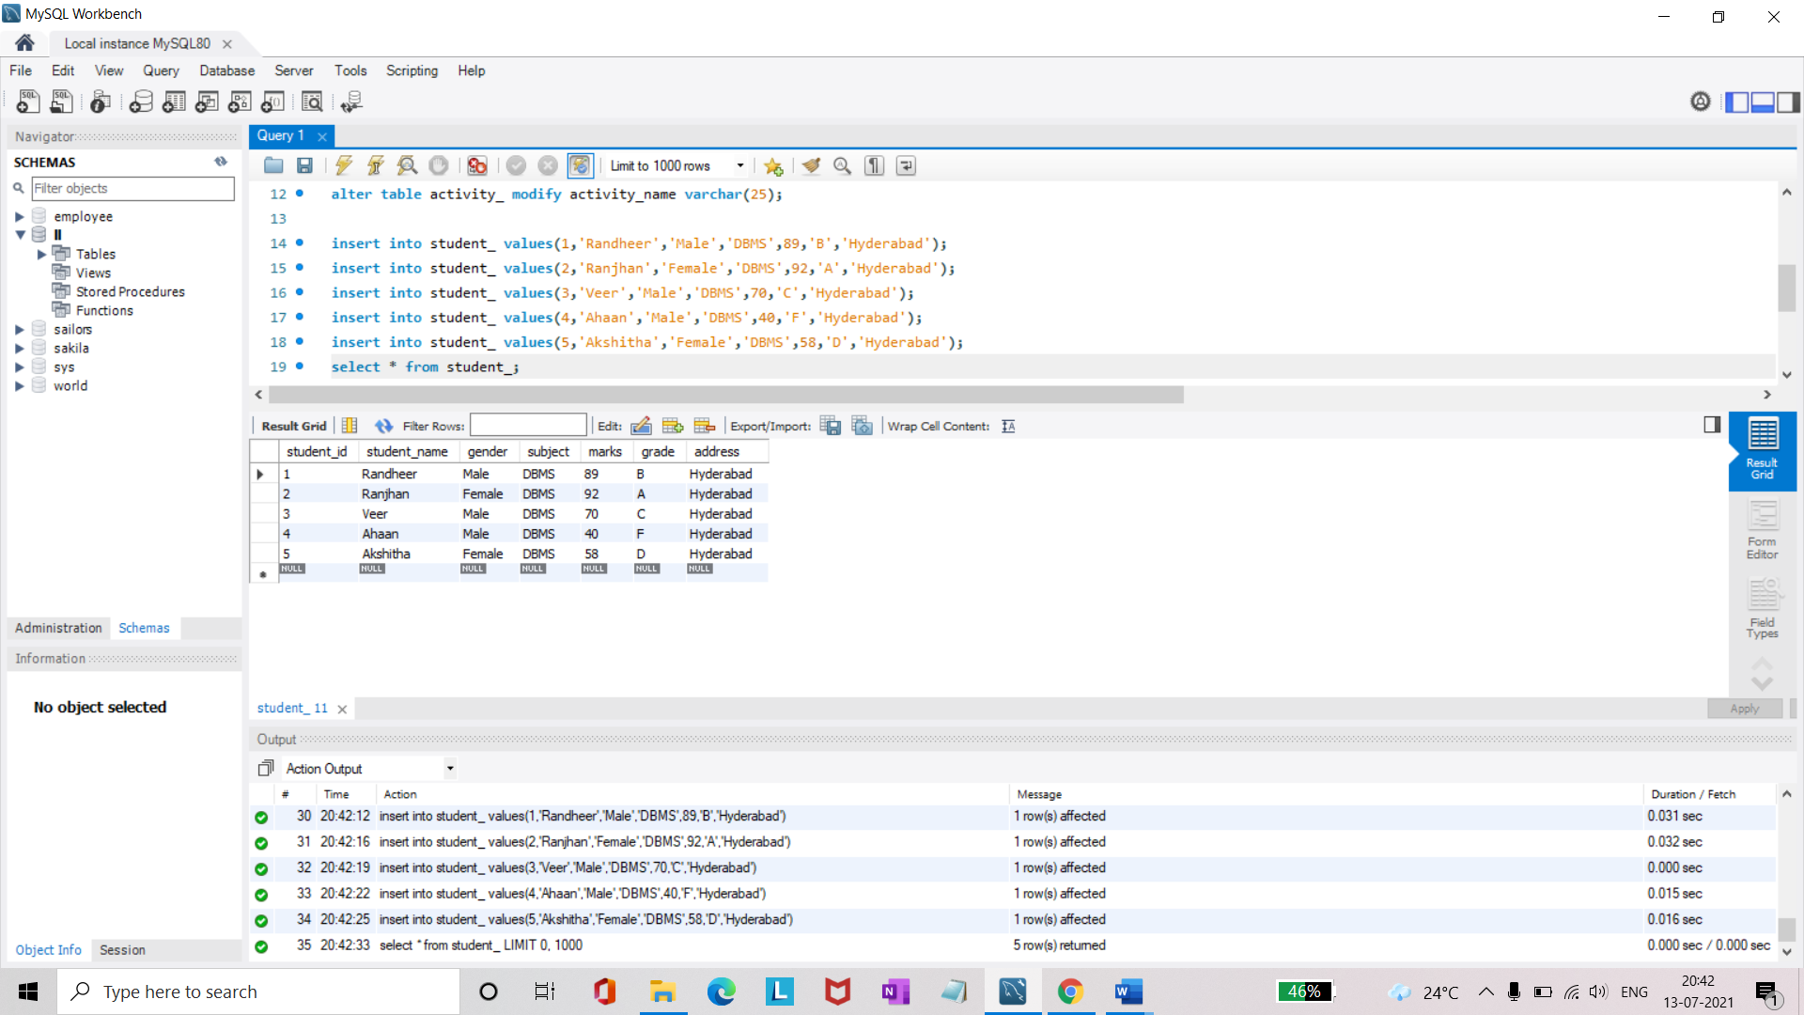

**insert into faculty_ values(101,'Rajesh','Java',50,'CSE');**

**insert into faculty_ values(102,'Bapiraju','C++',50,'CSE');**

**insert into faculty_ values(103,'Shiva','DBMS',50,'CSE');**

**insert into faculty_ values(104,'Amritha','Python',50,'IT');**

**insert into faculty_ values(105,'Vashma','C',50,'CSE');**

**select * from faculty_;**

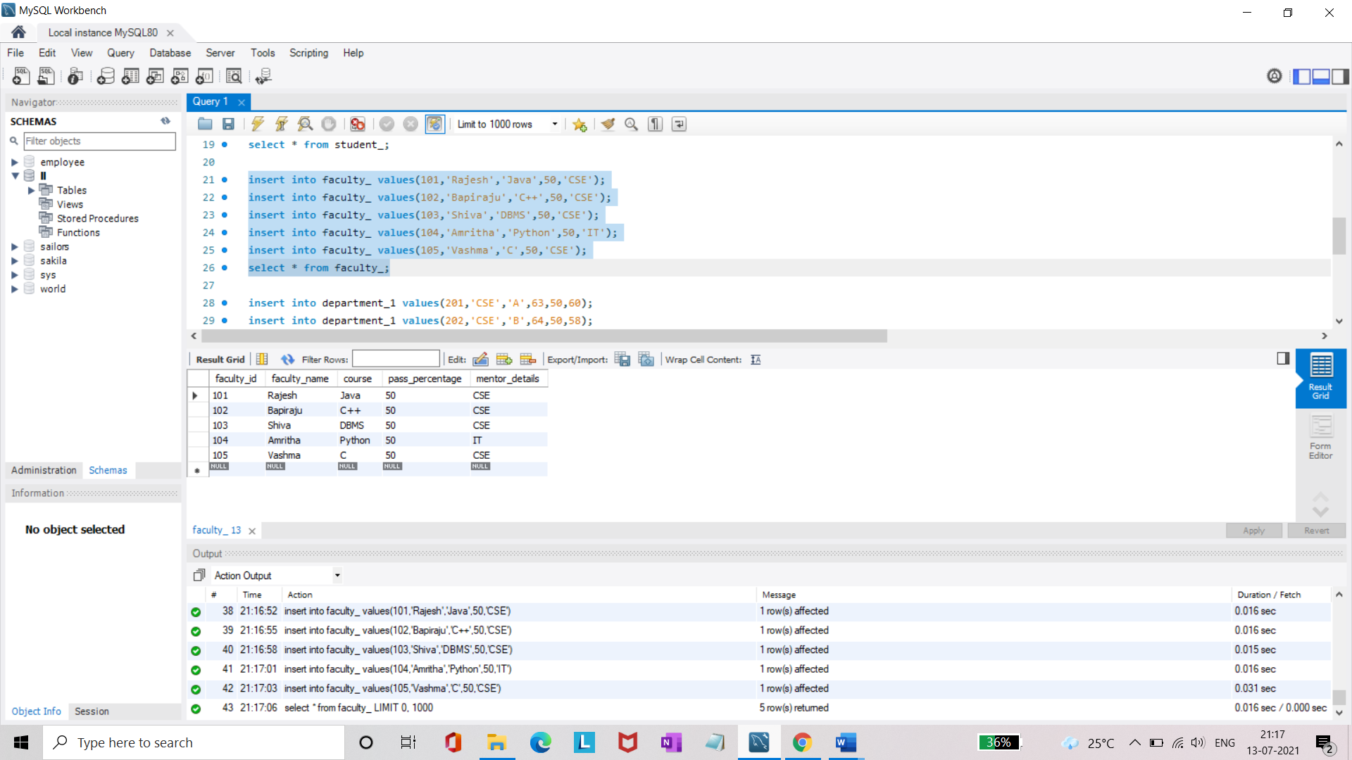

**insert into department_1 values(201,'CSE','A',63,50,60);**

**insert into department_1 values(202,'CSE','B',64,50,58);**

**insert into department_1 values(203,'CSE','C',65,50,56);**

**insert into department_1 values(302,'IT','A',60,50,55);**

**insert into department_1 values(204,'IT','B',60,50,50);**

**select * from department_1;**

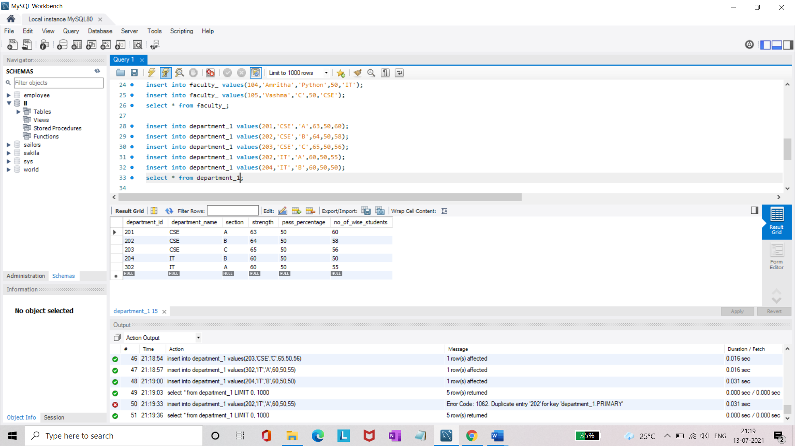

**insert into activity_ values(1,'Singing',10,5,'Priya');**

**insert into activity_ values(2,'Treasure hunt',30,2,'Arjun');**

**insert into activity_ values(3,'Debate',8,6,'Shiva');**

**insert into activity_ values(4,'Rangoli',16,15,'Shreya');**

**insert into activity_ values(5,'Blind coding',35,1,'Ajay');**

**select * from activity_;**

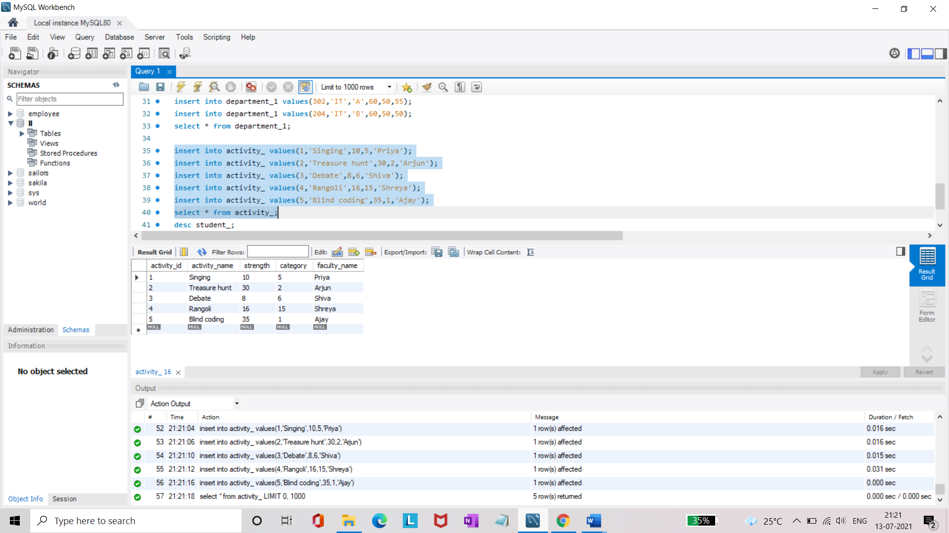

* Add attribute course to student table then insert values.
* Use update to set course for students.

**alter table student_ add(course varchar(20));**

**update student_ set course = "Python" where student_id = 1;**

**update student_ set course = "C" where student_id <6 and student_id>1;**

**select * from student_;**

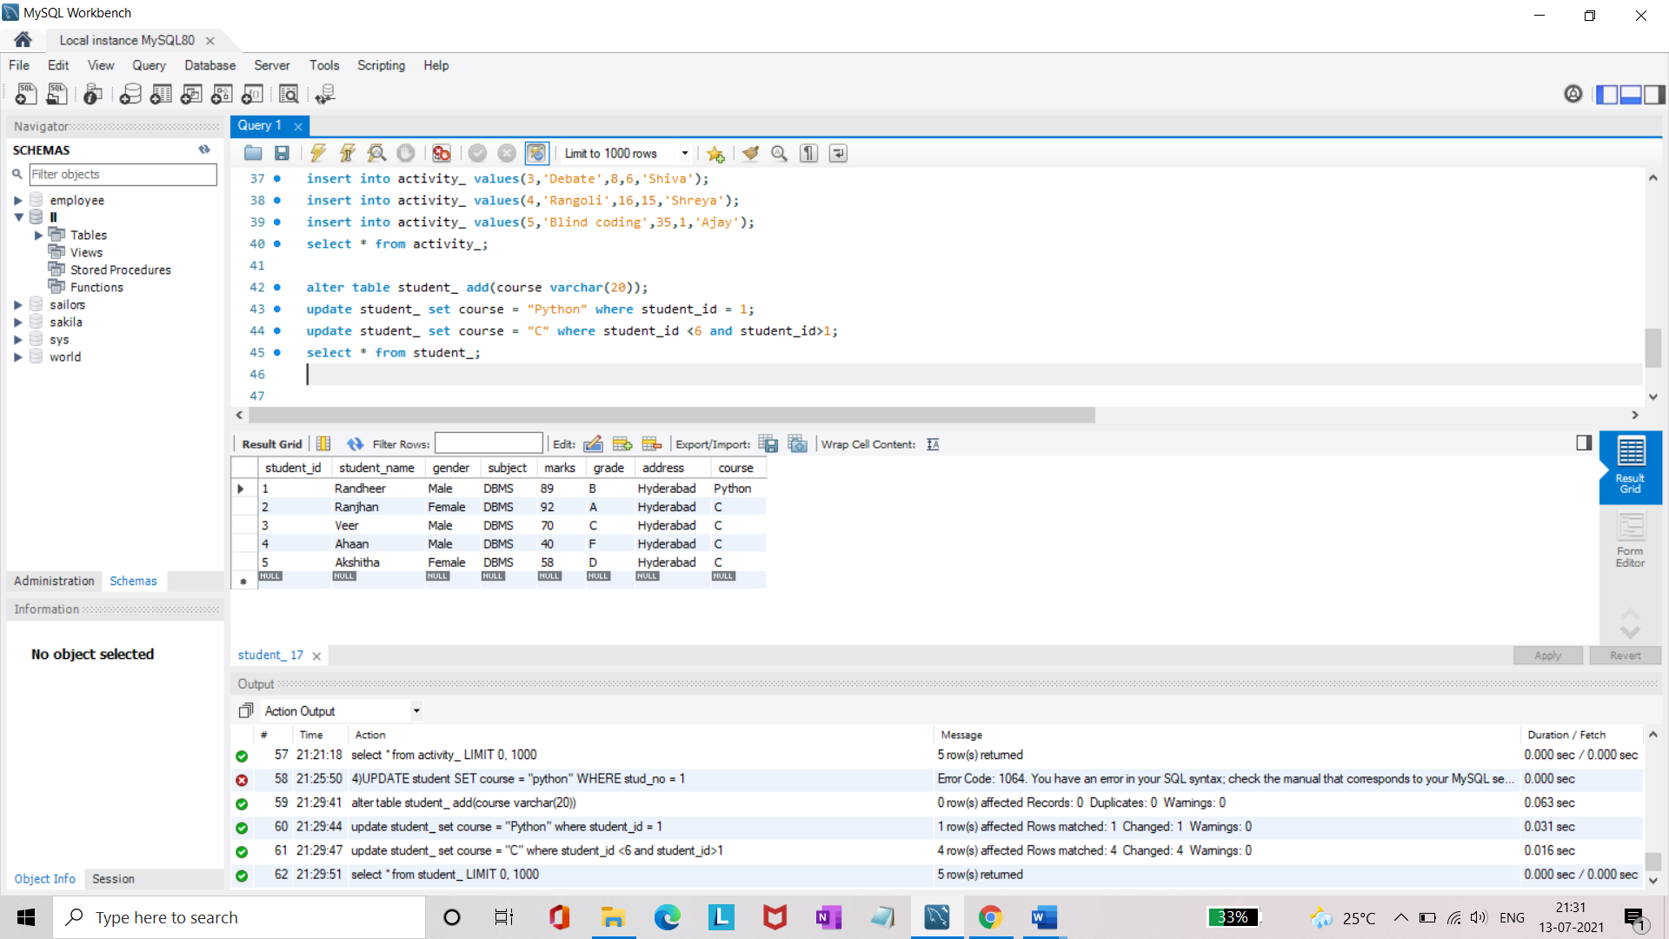

* Delete an attribute.

**alter table student_ drop column gender;**

**select * from student_;**

